**M3 - Improve the effectiveness of a website on the basis of a client review**

**Introduction**

In this report, I will explain the improvements that I will make. They are a few improvements and I will make these improvements due to the feedback form that I got.

**Feedback Form**

|  |  |  |
| --- | --- | --- |
| **Name** | **Description** | **Comment** |
| Bob | Contact Page | The animation on the Contact’s page needs to be the same colour as the background to make it suitable and look more professional. |
| Yunus | Contact Page | The banner is not level. It needs to be the same size like the other pages. |
| Salman | Transfer Centre | An ideal colour for the Transfer Centre would be more professional. I will suggest white. |

**Improvements**

**Before**

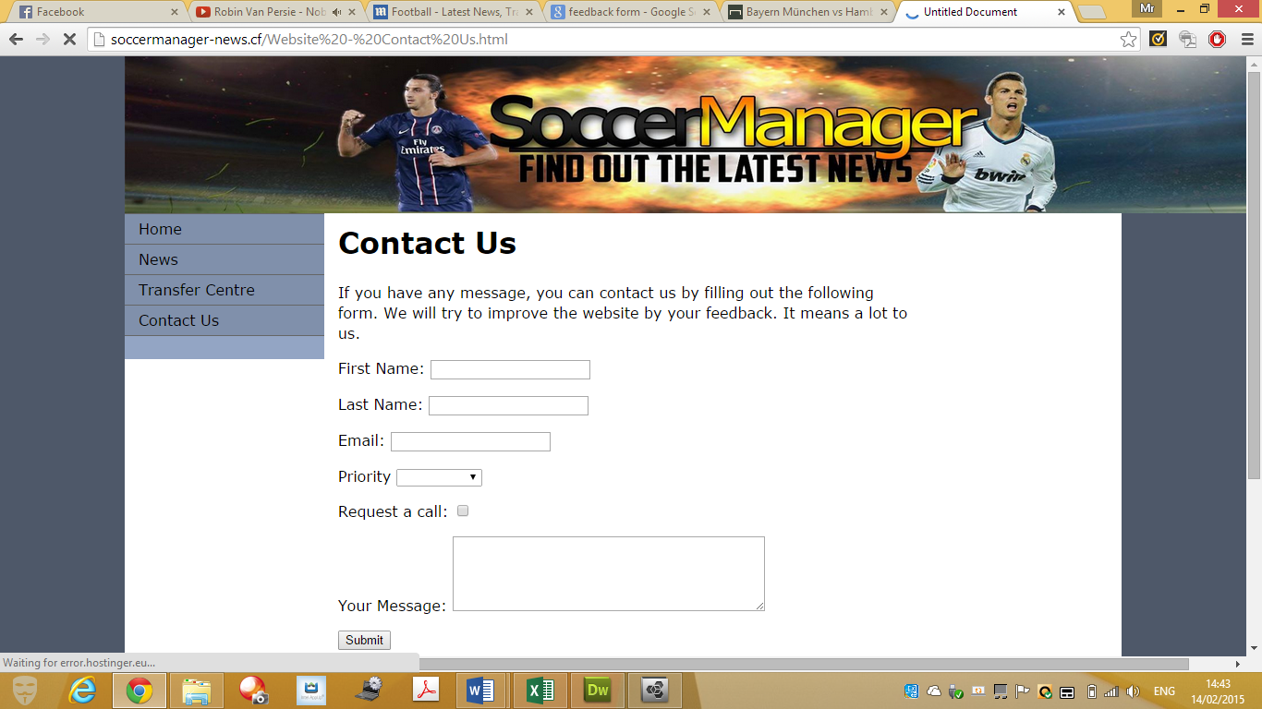

**After**

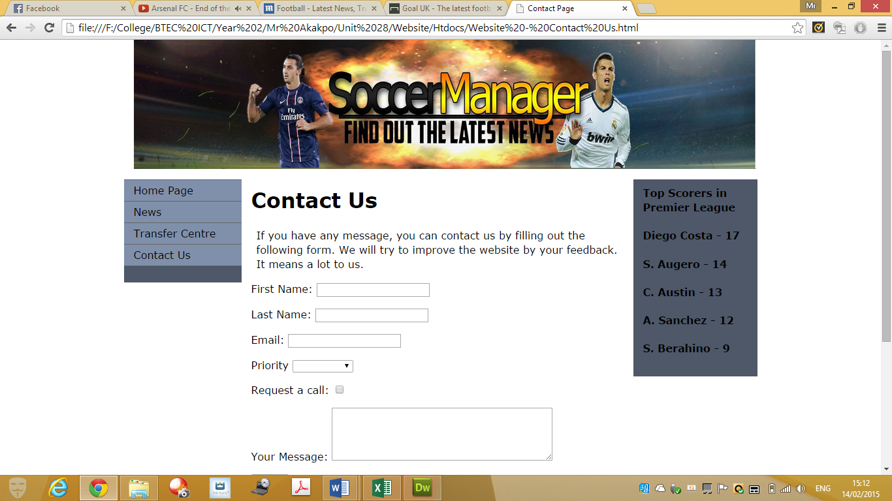

As you can see, the changes that I have made due to the feedback form that I have received. I changed the size and the background colour too.

1. 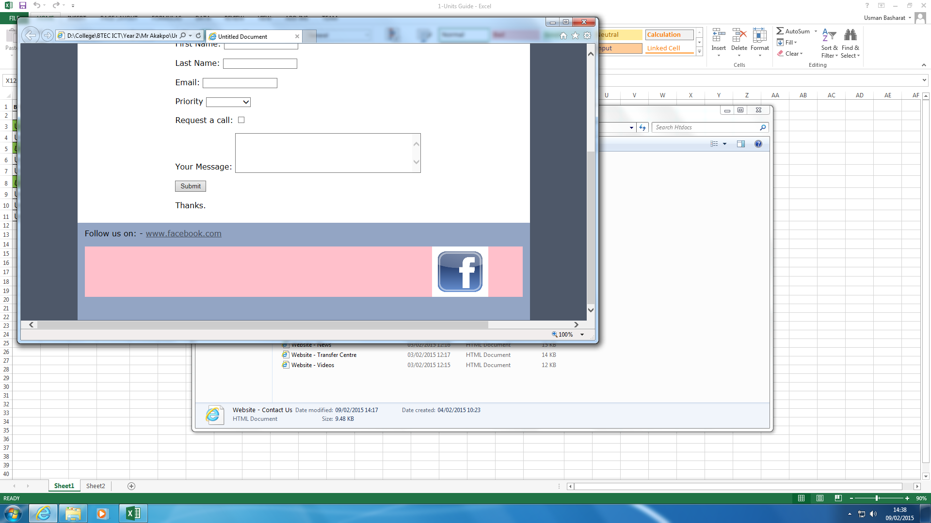

**Before**

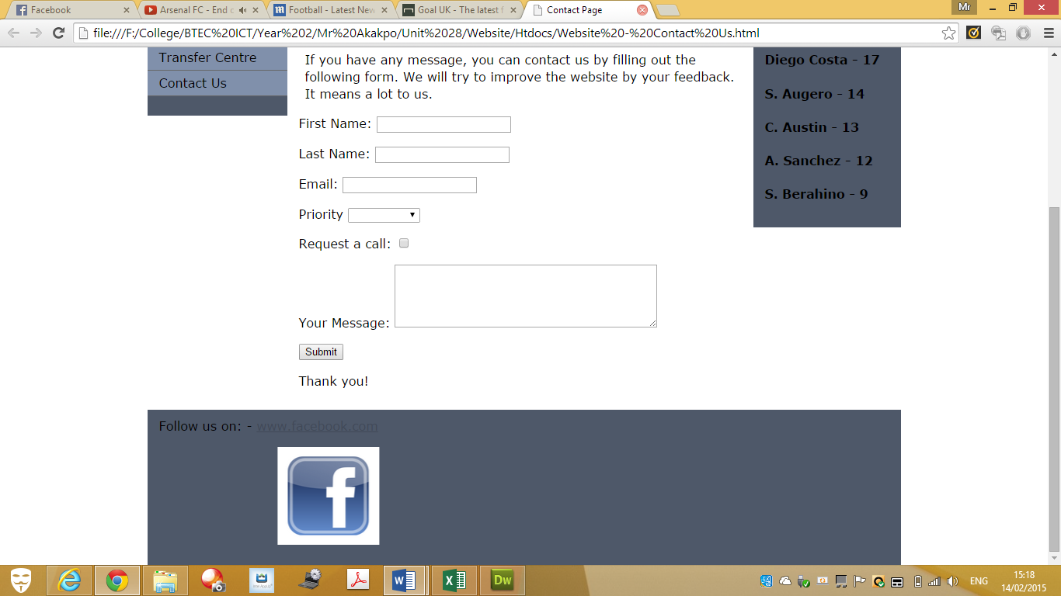**After**

One of the improvements that I suggested, with my peers too, is to change the colour. This is exactly what I have done.

Some of the changes that I have made is minor, but huge to me. The titles on the tab is changed to each of the page. For example, home page, it will say home page at the top. The colour for the Transfer Centre has been updated.

